Assignment 2: Mushroom Scenario

CIS 435

Section 56

Summer Quarter

School of Continuing Studies

Northwestern University

Daniel Prusinski

Business Intelligence Data Analyst

Target Corporation

Minneapolis, MN

In Compliance with Master of Science Predictive Analytics

|  |  |  |  |  |  |  |  |  |
| --- | --- | --- | --- | --- | --- | --- | --- | --- |
| A. |  |  |  |  |  |  |  |  |
| 1 |  |  |  |  |  |  |  |  |
| Entropy of Poisonus | | | |  | Entropy of Edible | | | |
| (-5/8 * Log5/8) + (-3/8 * Log3/8) | | | |  | (-3/8 * Log3/8) + (-5/8 * Log5/8) | | | |
| -0.625 | 0.625 |  |  |  | 0.375 | -0.375 |  |  |
| Log |  |  |  |  | Log |  |  |  |
| -0.678072 | Log |  |  |  | -1.4150370 |  |  |  |
| 0.423795 | Entropy of Poisonous |  |  |  | 0.5306389 |  |  |  |
|  |  |  |  |  |  |  |  |  |
| 0.375 | -0.375 |  |  |  | 0.625 | -0.625 |  |  |
| Log |  |  |  |  | Log |  |  |  |
| -1.4150370 |  |  |  |  | -0.678072 |  |  |  |
| 0.5306389 | Entropy of Not Poisonous |  |  |  | 0.423795 |  |  |  |
|  |  |  |  |  |  |  |  |  |
| 0.9544339 | Both Combined |  |  |  | 0.9544339 |  |  |  |

2. Gill Size, this can be seen visually from just looking at the data. This attribute gives you the most information gain. Info Gain is .04.

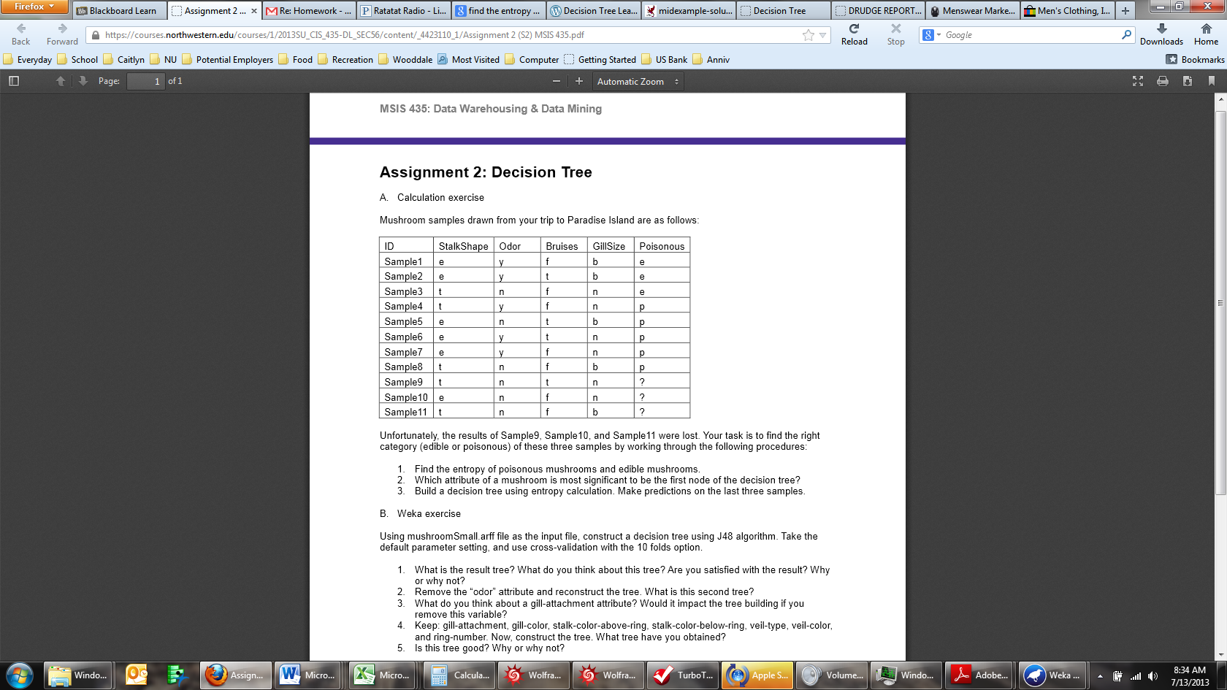

3. Build a decision tree using entropy calculation. Make predictions on the last three samples.

I am trying to predict the Poisonous, thus I cannot use that attribute in the decision tree.

I know that Gill Size is the best first split, therefore I will start with that.

Gill Size

Gill Size

N = 4

Gill Size

B = 4

|  |  |  |  |  |  |  |
| --- | --- | --- | --- | --- | --- | --- |
|  | B | N |  |  |  |  |
| P | 2 | 3 |  |  |  |  |
| E | 2 | 1 |  |  |  |  |
|  |  |  |  |  |  |  |
|  |  |  |  |  |  |  |
| Entropy of B | | | |  |  |  |
| (-4/8 * Log4/8) | | | |  |  |  |
| -0.5 | 0.5 |  |  |  |  |  |
| Log |  |  |  |  |  |  |
| -1 |  |  |  |  |  |  |
| 0.5 | Entropy, this is a terrible value | | | |  |  |
|  |  |  |  |  |  |  |
| Given B, the entropy for Poison is | | | |  |  |  |
| (2/4 * Log2/4) | | | |  |  |  |
| -0.5 | 0.5 |  |  |  |  |  |
| Log |  |  |  |  |  |  |
| -1 |  |  |  |  |  |  |
| 0.5 | Entropy, this is a terrible value | | | |  |  |
| So, you basically have a 50/50 chance | | | |  |  |  |
|  |  |  |  |  |  |  |
| Given N, the entropy for Poison is | | | |  |  |  |
| (-3/4 * Log3/4) | | | |  |  |  |
| -0.75 | 0.75 |  |  |  |  |  |
| Log |  |  |  |  |  |  |
| -0.415 |  |  |  |  |  |  |
| 0.31125 | Entropy, this shows that N is OK as an indicator of poison. | | | | | |
|  |  |  |  |  |  |  |
| Given N, the entropy for Edible is | | | |  |  |  |
| (-1/4 * Log1/4) | | | |  |  |  |
| -0.25 | 0.25 |  |  |  |  |  |
| Log |  |  |  |  |  |  |
| -2 |  |  |  |  |  |  |
| 0.5 | This shows that N is not a good indicator for non-poison. | | | | | |
|  |  |  |  |  |  |  |
|  | | | | | | |
|  | | | | |  |  |

ODOR – This follows the same math as above:

Y N

E 2 1

P 3 2

Odor Y = Edible =.52

= Poisonous =.44

Odor N = Edible =.52

=Poisonous = .38

|  |  |  |
| --- | --- | --- |
| Given these calculations, I would predict Sample 9 & 10 are edible. | | |
| Sample 11 has a 50/50 shot, I would simply not eat it, I would air on the side of this being poisonous. |  |  |



Preliminary Analysis: In this data set there are 933 examples represented in 23 attributes. Some attributes are binary, like bruises, gill-size, veil - type, stalk shape, and class, ye other attributes are categorical or continuous. I assume that the class attribute is the identifier of poisonous and non-poisonous. Visually, it is easy to see that the best first branch is gill size based on the vast number of instances that will be eliminated, 677 to be exact.

B.Weka exercise

Using mushroom Small.arff file as the input file, construct a decision tree using J48 algorithm.

Take the default parameter setting, and use cross-validation with the 10 folds option.

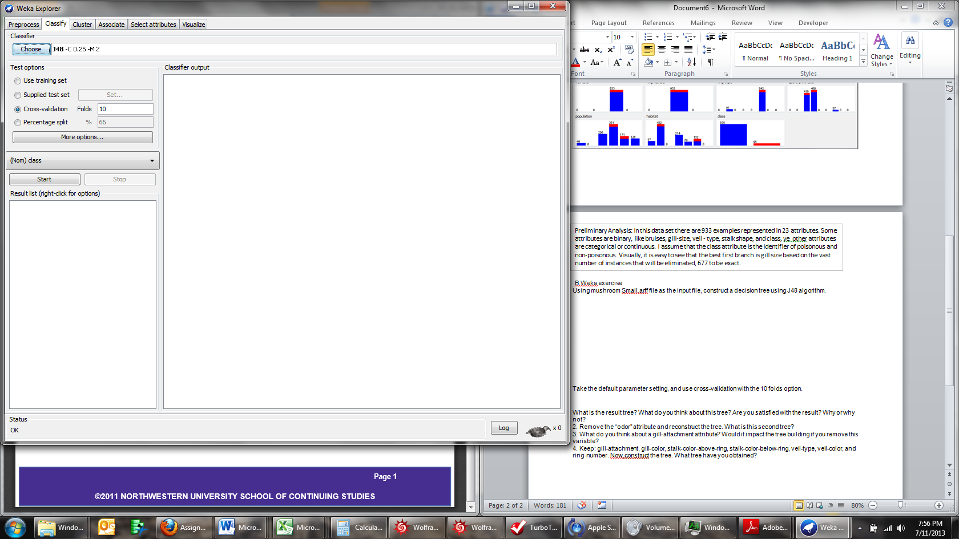

What is the result tree? What do you think about this tree? Are you satisfied with the result? Why or why not?

Scheme:weka.classifiers.trees.J48 -C 0.25 -M 2

Test mode:10-fold cross-validation

=== Classifier model (full training set) ===

J48 pruned tree

------------------

odor = a: e (332.0)

odor = c: e (0.0)

odor = f: e (0.0)

odor = l: e (323.0)

odor = m: e (0.0)

odor = n: e (183.0)

odor = p: p (95.0)

odor = s: e (0.0)

odor = y: e (0.0)

Number of Leaves : 9

Size of the tree : 10

=== Stratified cross-validation ===

=== Summary ===

Correctly Classified Instances 933 100 %

Incorrectly Classified Instances 0 0 %

Kappa statistic 1

Mean absolute error 0

Root mean squared error 0

Relative absolute error 0 %

Root relative squared error 0 %

Total Number of Instances 933

=== Detailed Accuracy By Class ===

TP Rate FP Rate Precision Recall F-Measure ROC Area Class

1 0 1 1 1 1 e

1 0 1 1 1 1 p

Weighted Avg. 1 0 1 1 1 1

=== Confusion Matrix ===

a b <-- classified as

838 0 | a = e

0 95 | b = p

J48 used Odor as the first branch. At first glance, this looks like the best attributes to classify the instances.

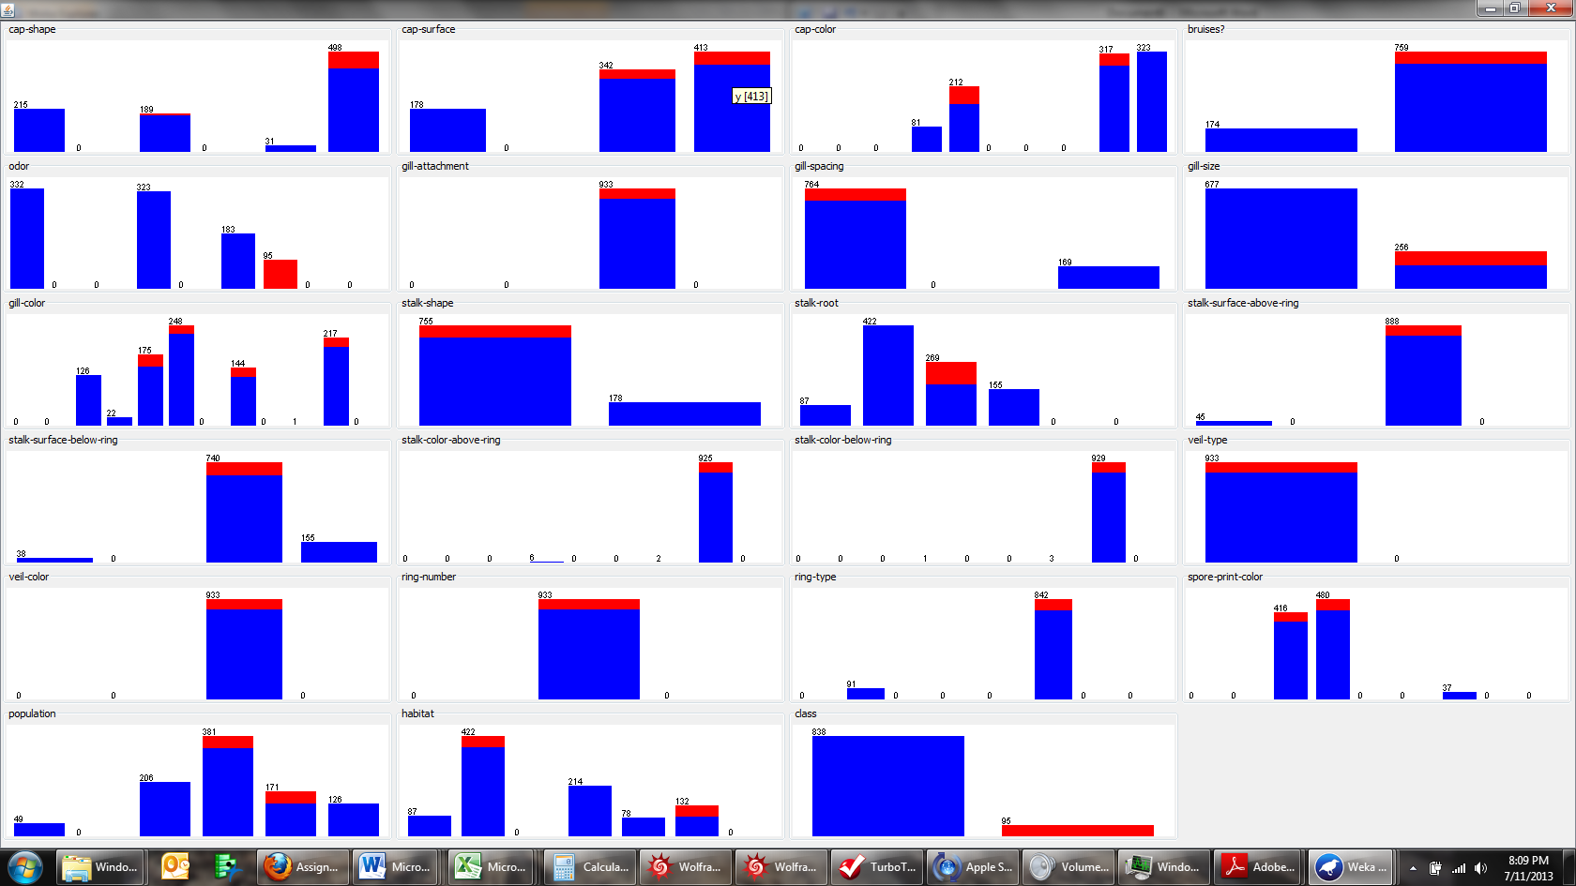

The decision tree below was generated from J48 with 10 folds. In my opinion, odor is very subjective and the margin for interpretation is too large to warrant using this attribute, especially when risking one’s life is on the line.



Preliminarily, this tree looks good, but it appears to be over fit. Every possible category seems to have a node, which is why I am apprehensive to how this would perform on non-training data. For someone to distinguish between 9 different smells is unrealistic, especially when odor and n and p are so close to one another.

2. Remove the “odor” attribute and reconstruct the tree.

Odor removed, only 22 attributes.

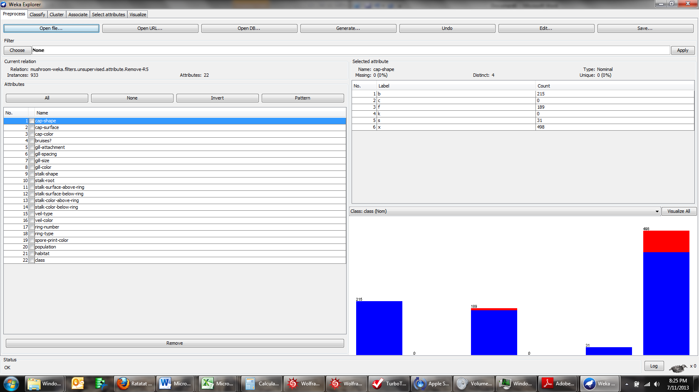

What is this second tree?

Scheme:weka.classifiers.trees.J48 -C 0.25 -M 2

Relation: mushroom-weka.filters.unsupervised.attribute.Remove-R5

Instances: 933

Attributes: 22

cap-shape

cap-surface

cap-color

bruises?

gill-attachment

gill-spacing

gill-size

gill-color

stalk-shape

stalk-root

stalk-surface-above-ring

stalk-surface-below-ring

stalk-color-above-ring

stalk-color-below-ring

veil-type

veil-color

ring-number

ring-type

spore-print-color

population

habitat

class

Test mode:10-fold cross-validation

=== Classifier model (full training set) ===

J48 pruned tree

------------------

gill-size = b: e (677.0)

gill-size = n

| cap-surface = f: e (121.0)

| cap-surface = g: e (0.0)

| cap-surface = s

| | gill-spacing = c: p (40.0)

| | gill-spacing = d: e (0.0)

| | gill-spacing = w: e (40.0)

| cap-surface = y: p (55.0)

Number of Leaves : 7

Size of the tree : 10

Time taken to build model: 0 seconds

=== Stratified cross-validation ===

=== Summary ===

Correctly Classified Instances 933 100 %

Incorrectly Classified Instances 0 0 %

Kappa statistic 1

Mean absolute error 0

Root mean squared error 0

Relative absolute error 0 %

Root relative squared error 0 %

Total Number of Instances 933

=== Detailed Accuracy By Class ===

TP Rate FP Rate Precision Recall F-Measure ROC Area Class

1 0 1 1 1 1 e

1 0 1 1 1 1 p

Weighted Avg. 1 0 1 1 1 1

=== Confusion Matrix ===

a b <-- classified as

838 0 | a = e

0 95 | b = p

This tree is based off of the “Gill-size, Cap-surface, and then Gill-spacing attributes, and has 7 leaves.

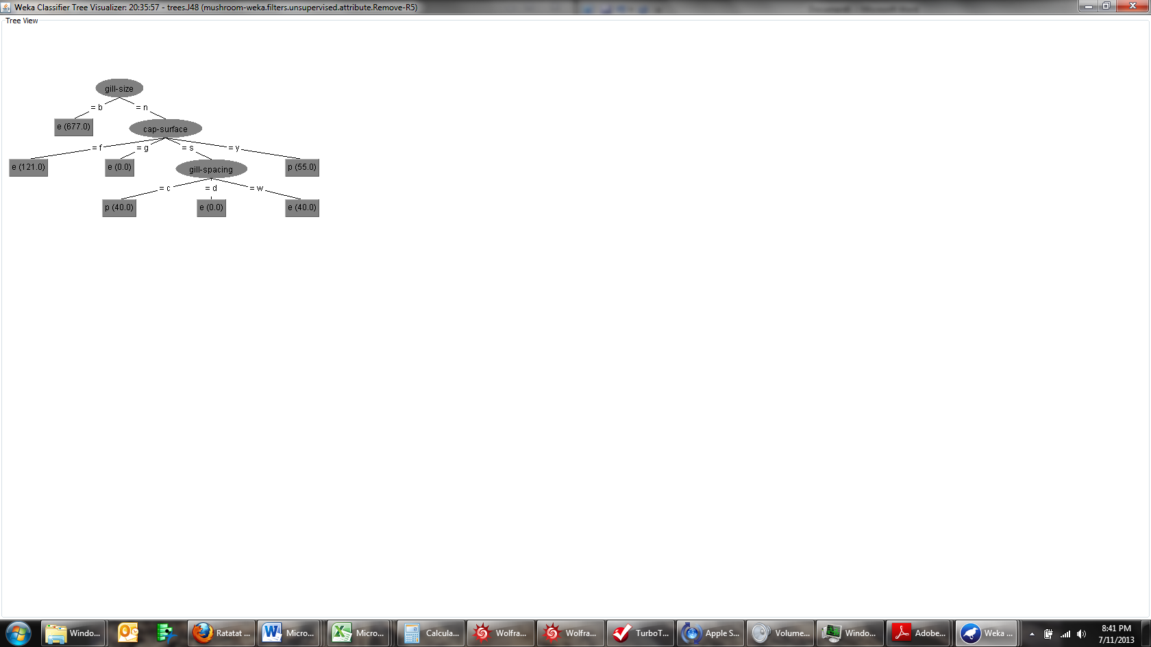

Gill size is a binary branch, and should be fairly easy to distinguish.

Cap – Surface has edible on one side of the spectrum and poisonous on the other, which should be relatively easy to distinguish.

Gill-Spacing is a 50/50 chance, but the spectrum is wide spread, so one could reason as to what the edible gill size is which would strengthen the odds.

3. What do you think about a gill-attachment attribute? Would it impact the tree building if you remove this variable?

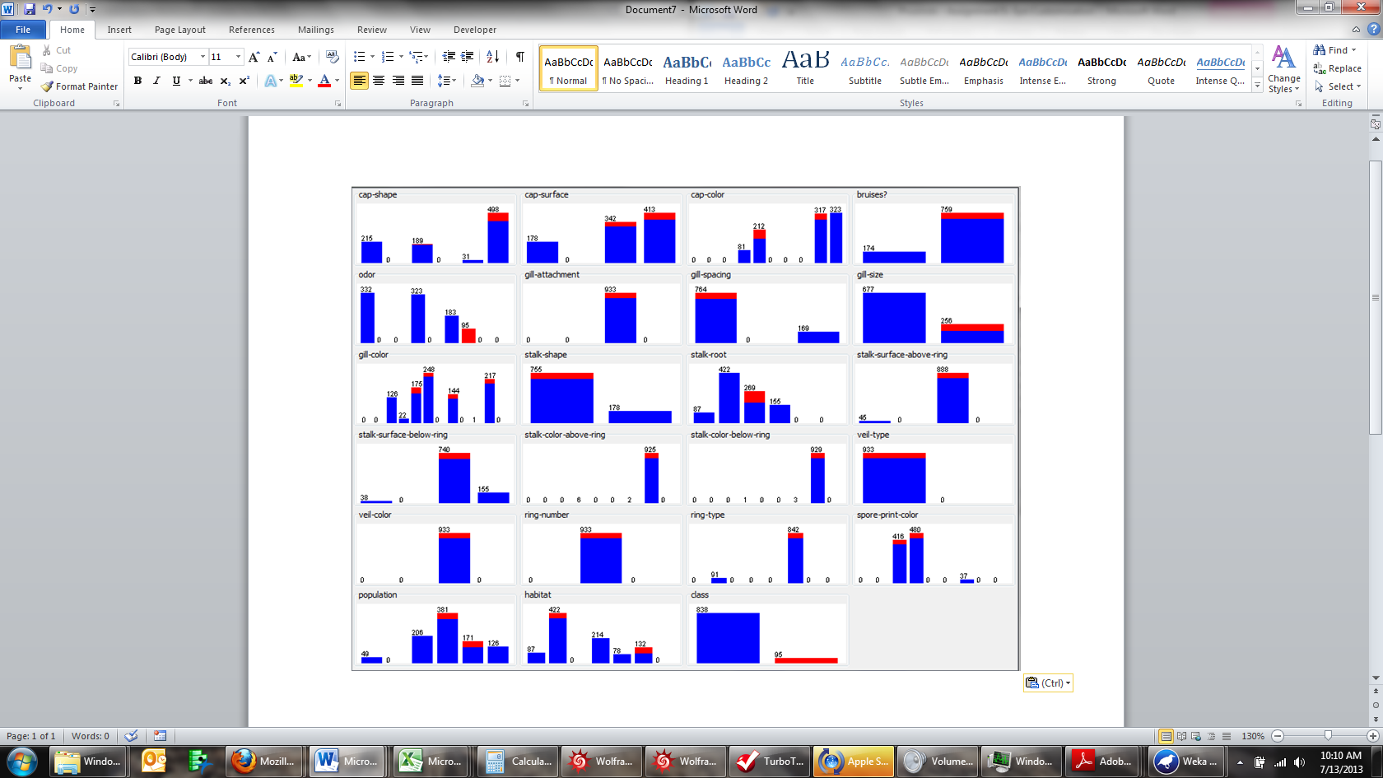

The gill attachment variable is pointless because all the instances fall within the same category. If this variable was removed, there would be no negative impact to the tree.

4. Keep: gill-attachment, gill-color, stalk-color-above-ring, stalk-color-below-ring, veil-type, veil-color, and ring-number. Now,construct the tree. What tree have you obtained?

Preliminary analysis:

Gill Attachment – This adds no value, see notes above.

Gill Cover – There are only 148 instances that can be removed with this attribute, and it too does not look like solid variable.

Stalk-Color-Above-Ring – Only 2 instances are in one category and 925 are in the other. This variable is not a good classifier either.

Stalk-Color-Below-Ring – This variable has 929 instances that are within one category, and this is a poor variable.

Veil type, Ring-Number, and Veil Cover are also complete variables where all the instances are in one category.

From the variables listed above, I suspect that the decision tree from these variables would be very poor based on how poorly they delineate poisonous mushrooms from edible.

Initial step of grouping all the variables:

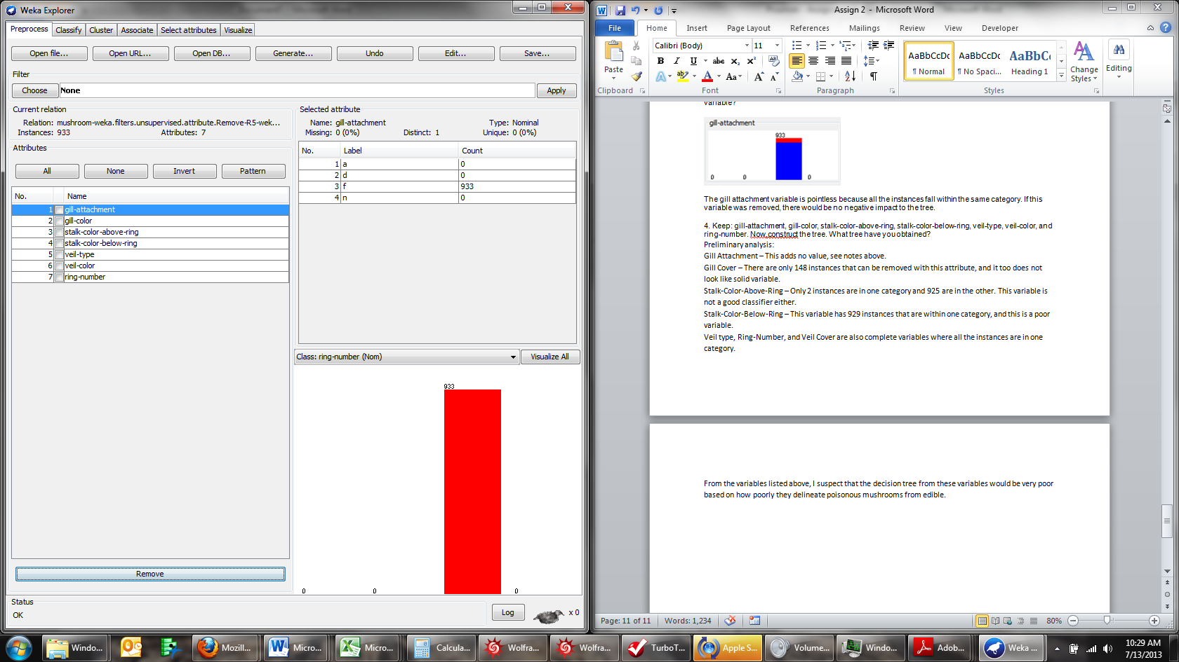

Result:

=== Run information ===

Scheme:weka.classifiers.trees.J48 -C 0.25 -M 2

Relation: mushroom-weka.filters.unsupervised.attribute.Remove-R5-weka.filters.unsupervised.attribute.Remove-R1-4,6-7,9-12,18-22

Instances: 933

Attributes: 7

gill-attachment

gill-color

stalk-color-above-ring

stalk-color-below-ring

veil-type

veil-color

ring-number

Test mode:10-fold cross-validation

=== Classifier model (full training set) ===

J48 pruned tree

------------------

: o (933.0)

Number of Leaves : 1

Size of the tree : 1

Time taken to build model: 0 seconds

=== Stratified cross-validation ===

=== Summary ===

Correctly Classified Instances 933 100 %

Incorrectly Classified Instances 0 0 %

Kappa statistic 1

Mean absolute error 0

Root mean squared error 0

Relative absolute error 0 %

Root relative squared error 0 %

Total Number of Instances 933

=== Detailed Accuracy By Class ===

TP Rate FP Rate Precision Recall F-Measure ROC Area Class

0 0 0 0 0 ? n

1 0 1 1 1 ? o

0 0 0 0 0 ? t

Weighted Avg. 1 0 1 1 1 0

=== Confusion Matrix ===

a b c <-- classified as

0 0 0 | a = n

0 933 0 | b = o

0 0 0 | c = t

As I suspected, this tree shows no helpful information in regard to discerning the edible form poisonous mushrooms.